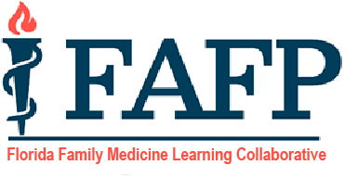

Florida Family Medicine Learning Collaborative
Webinar & Meeting Schedule

2026 Dates | Time | Presenter Name/Program | Topic
Monday, January 26, 2026 | 12:15 – 12:45 pm via Zoom | Dr. Terri Wall  Dr. Sonya Dominguez  Ascencion St Vincents Jacksonville | Resident Remediation/ Support Plan
Monday, February 23, 2026 | 12:15 – 12:45 pm via Zoom | Dr. Karim Hanna  USF Tampa General Hospital | AI in Resident Education
Monday, March 9, 2026 | 12:15 – 12:45 pm via Zoom | Dr. Nathan Falk  FSU Baycare Winter Haven | Creating and using ILPs
Friday, April 17, 2026 | 2:00-4:00 pm  Room TBD | FFMLC In-Person Meeting at FAFP Spring Summit, Orlando | LC In-Person Meeting
Monday, May 18, 2026 | 12:15 – 12:45 pm via Zoom | TBD | TBD
Monday, June 22, 2026 | 12:15 – 12:45 pm via Zoom | TBD | TBD
Monday, July 20, 2026 | 12:15 – 12:45 pm via Zoom | TBD | TBD
Monday, August 17, 2026 | 12:15 – 12:45 pm via Zoom | TBD | TBD
Monday. September 21, 2026 | 12:15 – 12:45 pm via Zoom | TBD | TBD
Monday, October 19, 2026 | 12:15 – 12:45 pm via Zoom | TBD | TBD
Monday, November 16, 2026 | 12:15 – 12:45 pm via Zoom | TBD | TBD
Friday, December 11, 2026 | 2:00-4:00 pm  Room TBD | FFMLC In-Person Meeting at FAFP Winter Summit, Amelia Island | LC In-Person Meeting

Updated: 11/13/2025

