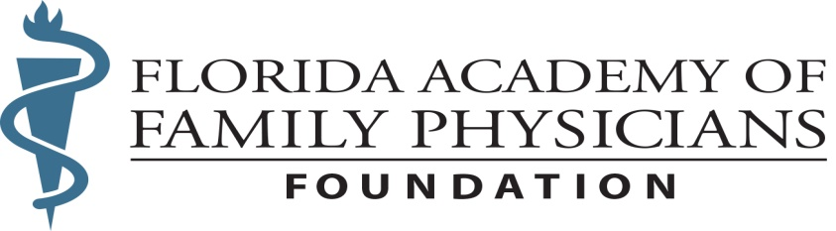

Improving the healthcare of all Floridians by funding education, research, and community outreach programs for medical students, residents, and family physicians - FAFP Foundation

2023 Paying it Forward
--Resident Educational Grant Campaign--
Up to $750 Resident Education Grant
The FAFP Foundation realizes that not all residents are capable of attending FAFP Continuing Medical Education weekend meetings due to financial limitations. After much consideration, the FAFP Foundation board recently approved the Paying it Forward campaign which works as follows:
- Florida Family Medicine Residency Programs with seven or more (7+) slots and paying for at least three residents to attend an FAFP CME weekend meeting will receive a $750 grant to help subsidize the associated travel expenses (i.e., send two get one free). Each program is limited to a single $750 grant per meeting.
- Residencies with six (6) or fewer slots can receive the following grant funding per residents they send to a CME weekend meeting: $250 for one resident, $500 for two and $750 for three.
- The grant is retroactive, so the application below must be filled out and sent to the FAFP Foundation no later than 30 days after the meeting to receive the funds. *

The FAFP Foundation hopes to expand the program in the future as financial resources increase, either by broadening the criteria or even opening up to individual resident educational grant requests. Resident directors and residents are encouraged discuss this opportunity and plan on their residents’ attendance accordingly. Any questions can be submitted to Ashleigh Huff at ahuff@fafp.org or 904-400-6185
APPLICATION (Please print)

Date: ________________ FL Residency Program Name: _______________________________________
Address for Funds to be Mailed: ________________________________________________________________
________________________________________________________________
FAFP CME Weekend:
April 21-23, 2023 Hilton Bonnet Creek, Orlando (Request must be received by May 10, 2023*)
June 30 July-2, 2023 Boca Raton Resort, Boca Raton (Request must be received by August 10, 2023*)
December 8-10, 2023 Ritz Carlton Amelia Island (Request must be received by January 11, 2024*)
Resident Attendance (Please print name**):

Name: ______________________________________ Name: ______________________________________

Name: ______________________________________ Name: ______________________________________
** Residents’ attendance will be verified by FAFP Foundation staff

Residency Director (Print): ____________________________________
Resident Director’s Signature: ____________________________________
Questions can be forwarded to Ashleigh Huff at ahuff@fafp.org or 904-400-6185

