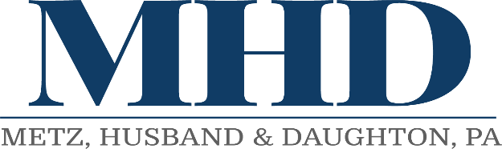
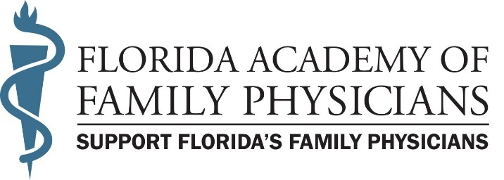

Florida Academy of Family Physicians
2024 Legislative Session– Week 5
February 9, 2024
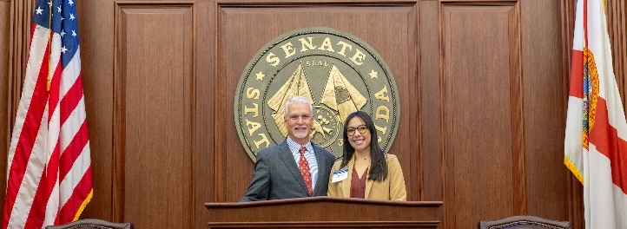

The legislature completed a frenetic week five that included the halfway point of the legislative session. Legislative committee schedules were brimming with bills as a vast majority of the House subcommittees and some Senate policy committees held their final meetings. The legislature also spent more time in floor sessions with budget debate being the primary focus; ultimately passing their respective budget bills to put the two chambers in place to start the budget conference process. The final four weeks of the legislative session will feature budget discussions, the negotiation of hundreds of bills, and top priority bills being pushed to the floor. FAFP member Diane Day, MD, from Gainesville served as Doctor of the Day on Thursday through the sponsorship of Senator Keith Perry. Thank you, Dr. Day, for your service!

FAFP Priority Legislation

Invalid Restrictive Covenants with Physicians – HB 11 by Rep. Dr. Joel Rudman (R-Navarre) and SB 458 by Sen. Jason Brodeur (R-Lake Mary) provide restrictive covenants which prohibit physician from practicing medicine within specified area for certain period of time are void and unenforceable. The FAFP is working with the sponsors to ensure appropriateness and address any concerns and misinformation used to prevent passage. While positive momentum for this priority legislation was achieved during its first year of being heard, the legislation will take several years to gain favorable passage.
HB 11 has not been heard this session. SB 458 was approved by the Senate Commerce Committee on Tuesday, 2/6, and Health Policy in week 4.

Legislation of Interest to Family Medicine (listed alphabetically)

Autonomous Practice for Certified Psychiatric Nurses – HB 771 by Rep. Webster Barnaby (R-Deland) and SB 936 by Sen. Ana Maria Rodriguez (R-Doral) authorize advanced practice registered nurses who are certified as psychiatric nurse practitioners to engage in autonomous practice under certain circumstances.
HB 771 was scheduled for a hearing but was temporarily postponed and not rescheduled for another hearing. SB 936 has not been heard this session.

Autonomous Practice by a Certified Registered Nurse Anesthetist – HB 257 by Rep. Mike Giallombardo (R-Cape Coral) and SB 810 by Sen. Blaise Ingoglia (R-Springhill) authorize certified registered nurse anesthetists to practice autonomously and authorize participation in the Medical Education Reimbursement and Loan Repayment Program.
HB 271 was scheduled for a hearing but was temporarily postponed and not rescheduled for another hearing. SB 810 has not been heard this session

Congenital Cytomegalovirus Screenings – SB 168 by Sen. Tina Polsky (D-Boca Raton) and HB 499 by Rep. Lauren Melo (R-Naples) expand the population which must undergo mandatory CCMV testing beyond the current population of infants who fail the hearing screening to include infants admitted to neonatal intensive care units, and newborns who are transferred to another facility for a higher level of care.
HB 499 was approved by the House Healthcare Subcommittee on Thursday, 2/1.
SB 168 was approved by the Senate Appropriations Committee on Health and Human Services on Thursday, 2/8.

Coverage for Skin Cancer Screenings – SB 56 by Sen. Gayle Harrell (R-Stuart) and HB 241 by Rep. Dr. Ralph Massullo (R-Inverness) require certain health insurance companies, to provide coverage and payment for annual skin cancer screenings performed by a licensed dermatologist without imposing any cost-sharing requirement.
HB 241 was approved by the House Appropriations Committee on Thursday, 2/8.
SB 56 will be heard in the Appropriations Committee on Agriculture, Environment, and General Government on Tuesday, 2/13.

Department of Health – SB 1582 by Sen. Ana Maria Rodriguez (R-Doral) and HB 1441 by Rep. Adam Anderson (R-Tarpon Springs) contain the Department of Health’s legislative package. The bills exempt environmental health technicians from certain certification requirements under certain circumstances, create the Andrew John Anderson Rare Pediatric Disease Grant Program within the department, provide that any health care practitioner present at a birth or responsible for primary care during the neonatal period has the primary responsibility of administering certain screenings, and revise hearing loss screening requirements to include infants and toddlers.
HB 1441 was approved by the House Health Care Appropriations Subcommittee on Monday, 1/29.
SB 1582 was approved by the Senate Health Policy Committee on Tuesday, 2/6.

Emergency Refills of Insulin and Insulin-related Supplies or Equipment – HB 201 by Rep. Melanie Bell (R-Fort Meade) and SB 516 by Sen. Ana Maria Rodriguez (R-Doral) authorize emergency refill of specified amounts of insulin and insulin-related supplies or equipment.
HB 201 has passed all committees and is available for consideration on the House calendar.
SB 516 was approved by the Senate Appropriations Committee on Health and Human Services on Thursday, 2/8.

Health Care - SB 7016 by the Committee on Health Policy and HB 1549 by Rep. Michael Grant (R-Port Charlotte) are the “Live Healthy” initiative. The bills revise the purpose of the Dental Student Loan Repayment Program, revise the Florida Reimbursement Assistance for Medical Education (FRAME) Program, require the Department of Health to provide annual reports to the Governor and the Legislature on specified student loan repayment programs, create the Health Care Screening and Services Grant Program, create an advanced birth center designation, create the Training, Education, and Clinicals in Health (TEACH) Funding Program, create the emergency department diversion requirements for hospitals and Medicaid managed care plans, create limited licenses for graduate assistant physicians, create temporary certificates for physician assistants and advanced practice registered nurses to practice in areas of critical need and provide that Florida will enter into the Interstate Medical Licensure Compact, the Audiology and Speech-Language Pathology Interstate Compact, and the Physical Therapy Licensure Compact.
HB 1549 was approved by the House Health Care Appropriations Committee on Tuesday, 2/6.
SB 7016 passed the Senate 39-0 on 1/18.

Health Care Innovation – SB 7018 by the Senate Health Policy Committee and HB 1501 by Rep. Karen Gonzalez Pittman (R-Tampa) create the Health Care Innovation Council within the Department of Health and require the department to administer a revolving loan program for applicants seeking to implement certain health care innovations in this state, and authorize the department to contract with a third party to administer the program.
HB 1501 was approved by the House Health Care Appropriations Committee on Tuesday, 2/6.
SB 7018 passed the Senate 39-0 on 1/18.

Health Care - Public Records/ Interstate Medical Licensure Compact, the Audiology and Speech-language Pathology Interstate Compact, and the Physical Therapy Licensure Compact – HB 7041 by the House Select Committee on Health Innovation and SB 322 by Sen. Colleen Burton (R-Lakeland) provide a public records exemption relating to records in the Interstate Medical Licensure Compact, the Audiology and Speech-language Pathology Interstate Compact, and the Physical Therapy Licensure Compact created in the Live Healthy Initiatives.
HB 7041 was approved by the House Ethics, Elections and Open Government Subcommittee on Monday, 1/29.
SB 322 passed the Senate 39-0 on 1/18.

Health Care Practitioner Titles and Designations – SB 1112 by Sen. Gayle Harrell (R-Stuart) and HB 1295 by Rep. Dr. Ralph Massullo (R-Inverness) provide that, for specified purposes, the use of specified titles or designations in connection with one’s name constitutes the practice of medicine or the practice of osteopathic medicine, revise grounds for disciplinary action relating to a practitioner’s use of such titles or designations in identifying himself or herself to patients or in advertisements for health care services, and require certain health care practitioners to wear name tags.
HB 1295 was approved by the House Healthcare Regulation Subcommittee on 2/2.
SB 1112 has passed all Senate Committees and is available on the Senate calendar.

Interstate Mobility - HB 1381 by Rep. Danny Alvarez (R-Riverview) and SB 1600 by Sen. Jay Collins (R-Tampa) require respective boards of occupations, or the Department of Business and Professional Regulation (DBPR) if there is no board to issue license or certificate to applicants who meet specified conditions, require DOH to verify certain information using National Practitioner Data Bank, specify circumstances under which person is ineligible for licensing, authorize boards or DOH to revoke license upon specified finding, authorize boards or DOH to require that applicants successfully complete jurisprudential examination, revise licensure by endorsement requirements for multiple health care practitioner licenses.
HB 1381 has not been heard this Session.
SB 1600 was approved by the Senate Regulated Industries Committee on Monday, 1/29.

Intravenous Vitamin Treatment – HB 227 by Rep. Alina Garcia (R-Miami) and SB 672 by Sen. Alexis Calatayud (R-Miami) provide requirements for persons administering intravenous vitamin treatment and require the Board of Nursing, and Board of Medicine & Board of Osteopathic Medicine to adopt rules establishing procedures to administer intravenous vitamin treatment and emergency protocols.
HB 227 has passed all House committees and is available on the House calendar..
SB 672 has not been heard this Session.

Naturopathic Medicine - HB 843 by Rep. David Smith (R-Winter Springs) and SB 898 by Sen. Ileana Rodriguez (R-Doral) create the Board of Naturopathic Medicine within the Department of Health (DOH). HB 845 also by Rep. David Smith and SB 900 by Sen. Ileana Rodriguez require the Board of Naturopathic Medicine to establish certain fees licensure by examination and licensure by endorsement, respectively, of naturopathic physicians.
HB 843 was temporarily postponed in the House Appropriations Committee on Thursday, 2/8.
HB 845 was temporarily postponed in the House Healthcare Regulation Subcommittee on 1/24.
SB 898 has not been heard this Session.
SB 900 has not been heard this Session.

Payments for Health Care Providers and Surgical Procedures under Workers' Compensation – HB 161 by Rep. Dan Daley (D-Coral Springs) and SB 362 by Sen. Jennifer Bradley (R-Fleming Island) increase the maximum amounts of certain witness fees related to workers' compensation cases and increases maximum reimbursements for physicians & surgical procedures under workers' compensation.
HB 161 was approved by the House Insurance and Banking Subcommittee on 1/26.
SB 362 was approved by the Senate Fiscal Policy Committee on Wednesday, 2/7.

Pharmacy – SB 444 by Sen. Jay Collins (R-Tampa) and HB 493 by Rep. Spencer Roach (R-North Fort Myers) authorize registered pharmacy technicians to dispense medicinal drugs under certain circumstances, define the terms “supervising pharmacy” and “telepharmacy,” provide requirements for remote-site pharmacies, exempt registered pharmacists serving as prescription department managers for remote-site pharmacies from certain practice limitations.
HB 493 was approved by the House Healthcare Regulation Subcommittee on Thursday, 2/1.
SB 444 has not been heard this Session.

Practice of Acupuncture – SB 614 by Sen. Ed Hooper (R-Palm Harbor) and HB 1405 by Rep. Thad Altman (R-Indian Harbour Beach) revise education requirements for acupuncture licensure, beginning on specified dates, authorize acupuncturist assistants to assist in the practice of acupuncture under the direct supervision of an acupuncturist, revise continuing education requirements for acupuncture licensure renewal, require the Board of Acupuncture to establish and maintain a formulary for acupoint injection therapies, and specify requirements for the formulary.
HB 1405 was approved by the House Healthcare Regulation Subcommittee on Thursday, 2/1.
SB 614 has not been heard this Session.

Prescriptive Authority for Psychologists – HB 955 by Rep. Gallop Franklin (D-Tallahassee) and SB 1282 by Sen. Corey Simon (R-Tallahassee) require the Board of Psychology to certify psychologists to exercise prescriptive authority if they meet specified criteria, specify requirements for the prescribing of drugs and controlled substances by a prescribing psychologists, and require the Board of Psychology to establish an interim panel for a specified purpose by a specified date.
Neither bill has been heard this Session.

Recovery of Damages in Claims for Medical Negligence – HB 77 by Rep. Spencer Roach (R-North Fort Myers), HB 129 by Rep. Vicki Lopez (R-Coral Gables) and Rep. Mike Beltran (R-Apollo Beach), SB 442 by Sen. Lauren Book (D-Plantation) SB 248 by Sen. Clay Yarborough (R-Jacksonville) and SB 310 by Sen. Jonathan Martin (R-Fort Myers) expand the application of the Florida Wrongful Death Act by repealing exceptions that prohibit certain parents and children of a deceased patient who dies due to medical negligence from recovering noneconomic damages. SB 248 was amended to limit non-economic damages that apply to all actions for medical negligence.
HB 77, SB 442 and SB 310 have not been heard this Session.
SB 248 was approved by the Senate Judiciary Committee on 1/22.

Short-acting Bronchodilator Use in Public and Private Schools – HB 883 by Rep. Traci Koster (R-Tampa) and SB 962 by Sen. Ed Hooper (R-Palm Harbor) authorize schools to acquire stock a supply of short-acting bronchodilators to administer to students in respiratory distress.
HB 883 was approved by the House PreK-12 Appropriations Subcommittee on 1/24.
SB 962 was approved by the Senate Health Policy Committee on Tuesday, 2/6.

Sickle Cell Care Management and Treatment Education for Physicians – HB 349 by Rep. Felicia Simone Robinson (D-Miami Gardens) and SB 552 by Sen. Darryl Rouson (D-St. Petersburg) require education on sickle cell care management and treatment protocols for physicians to renew a license and requires the Department of Health to evaluate physician survey results and annually report to Governor and Legislature on patient outcomes as result of such education.
HB 349 was approved by the House Healthcare Regulation Subcommittee on Thursday, 2/1.
SB 552 has not been heard this Session.

