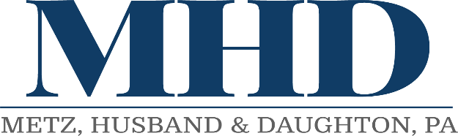
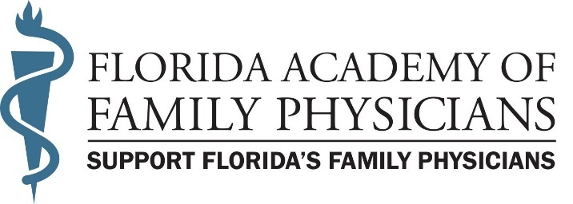

Florida Academy of Family Physicians
2024 Legislative Session– Week 6
February 16, 2024

The legislature spent this week moving into the final phase of the legislative session with policy bills dominating legislative committees’ agendas hoping to receive their final committee hearing before being considered on the House and Senate floor. Both the House and Senate also continued the general spirit of cooperation as the Senate acted on the House Speaker Renner’s priority legislation – Social Media Restrictions, and the House acted on the Senate President Passidomo’s priority legislation – Live Healthy. The much-anticipated budget conference process is expected to officially commence next week as the session tracks towards an on-time completion on March 8th.

Family medicine was represented a record four of five days last week as followings (L to R below)
-2/12-Kamini Geer, MD, and resident Maleeha Ahmad, MD, sponsored by Rep. David Smith
-2/13- Seetha Venkateswaran, MD, and resident Kandi Campbell, MD, sponsored by Rep. Dan Daley
-2/14- Michale Allison, MD, and resident Kelly Delgado, MD, sponsored by Senator Hooper
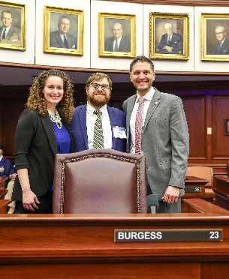
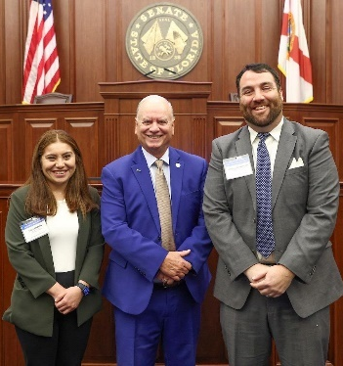
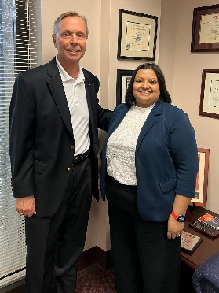
-2/15- Maribeth Williams, MD, and resident Tom Clem, MD, sponsored by Senator Burgess

As you can see, family medicine residents from around Florida are participating in the process making the experience and impact that much more meaningful. Not to mention, the FAFP leaders “leading” by example with Drs. Geer and Williams serving on the FAFP Board, Dr. Venkateswaran serving on Gov’t Relations Committee, and Dr. Allison a consistent contributor as a speaker. If you are interested in engaging in the process, please contact Jay Millson (jmillson@fafp.org).

FAFP Priority Legislation
Invalid Restrictive Covenants with Physicians – HB 11 by Rep. Dr. Joel Rudman (R-Navarre) and SB 458 by Sen. Jason Brodeur (R-Lake Mary) provide restrictive covenants which prohibit physician from practicing medicine within specified area for certain period of time are void and unenforceable. The FAFP is working with the sponsors to ensure appropriateness and address any concerns and misinformation used to prevent passage. While positive momentum for this priority legislation was achieved during its first year of being heard, the legislation will take several years to gain favorable passage.
SB 458 was approved by the Senate Commerce Committee on Tuesday, 2/6, and Health Policy in week 4. HB 11 was not heard in committee this session.

Legislation of Interest to Family Medicine (listed alphabetically)

Background Screening Requirements for Health Care Practitioners – HB 975 by Rep. Dana Trabulsky (R-Fort Pierce) and SB 1008 by Sen. Erin Grall (R-Fort Pierce) expand certain background screening requirements to apply to all health care practitioners, rather than specified practitioners.
HB 975 was approved by the House Health Care Appropriations Subcommittee on 2/7. SB 1008 was approved by the Senate Appropriations Committee on HHS on Tuesday, 2/13.

Civil Liability for the Wrongful Death of an Unborn Child – SB 476 by Sen. Erin Grall (R-Vero Beach) and HB 651 by Rep. Jenna Persons-Mulicka (R-Ft Meyers) expand Florida’s Wrongful Death Act to allow the parents of an unborn child to recover noneconomic damages for mental pain and suffering from a person who is responsible for the death of the unborn child.
SB 476 was approved by the Judiciary Committee on 2/5 and Fiscal Policy Committee on 2/15.
HB 651 was approved by the House Civil Justice Committee on Thursday, 1/18.

Congenital Cytomegalovirus Screenings – SB 168 by Sen. Tina Polsky (D-Boca Raton) and HB 499 by Rep. Lauren Melo (R-Naples) expand the population which must undergo mandatory CCMV testing beyond the current population of infants who fail the hearing screening to include infants admitted to neonatal intensive care units, and newborns who are transferred to another facility for a higher level of care.
HB 499 was approved by the House Health Care Appropriations Subcommittee on Tuesday, 2/13.
SB 168 was approved by the Senate Appropriations Committee on Health and Human Services on Thursday, 2/8.

Coverage for Skin Cancer Screenings – SB 56 by Sen. Gayle Harrell (R-Stuart) and HB 241 by Rep. Dr. Ralph Massullo (R-Inverness) require Florida State Group Health Insurers to provide coverage and payment for annual skin cancer screenings performed by a licensed dermatologist without imposing any cost-sharing requirement.
HB 241 was approved by the House Health and Human Services Committee on Thursday, 2/15.
SB 56 was approved by the Appropriations Committee on Agriculture, Environment, and General Government on Tuesday, 2/13.

Coverage of Biomarker Testing – SB 964 by Sen. Alexis Calatayud (R-Miami) and HB 885 by Rep. Karen Gonzalez Pittman (R-Tampa) require the Agency for Health Care Administration and managed care plans to provide specified coverage of biomarker testing under the Medicaid program. The bills also require State Group Insurance to cover biomarker testing.
HB 885 was approved by the House Appropriations Committee on 2/8.
SB 964 was approved by the Senate Appropriations Committee on Health and Human Services on Tuesday, 2/13.

Department of Health – SB 1582 by Sen. Ana Maria Rodriguez (R-Doral) and HB 1441 by Rep. Adam Anderson (R-Tarpon Springs) contain the Department of Health’s legislative package. The bills exempt environmental health technicians from certain certification requirements under certain circumstances, create the Andrew John Anderson Rare Pediatric Disease Grant Program within the department, provide that any health care practitioner present at a birth or responsible for primary care during the neonatal period has the primary responsibility of administering certain screenings, and revise hearing loss screening requirements to include infants and toddlers.
HB 1441 was approved by the House Health Care Appropriations Subcommittee on Monday, 1/29.
SB 1582 will be heard in the Senate Appropriations Committee on Health and Human Services on Tuesday, 2/20.

Emergency Refills of Insulin and Insulin-related Supplies or Equipment – HB 201 by Rep. Melanie Bell (R-Fort Meade) and SB 516 by Sen. Ana Maria Rodriguez (R-Doral) authorize emergency refill of specified amounts of insulin and insulin-related supplies or equipment.
HB 201 passed the House 118-0 on Thursday, 2/15. SB 516 was approved by the Senate Appropriations Committee on Health and Human Services on Thursday, 2/8.

Health Care - SB 7016 by the Committee on Health Policy and HB 1549 by Rep. Michael Grant (R-Port Charlotte) are the “Live Healthy” initiative. The bills revise the purpose of the Dental Student Loan Repayment Program, revise the Florida Reimbursement Assistance for Medical Education (FRAME) Program, require the Department of Health to provide annual reports to the Governor and the Legislature on specified student loan repayment programs, create the Health Care Screening and Services Grant Program, create an advanced birth center designation, create the Training, Education, and Clinicals in Health (TEACH) Funding Program, create the emergency department diversion requirements for hospitals and Medicaid managed care plans, create limited licenses for graduate assistant physicians, create temporary certificates for physician assistants and advanced practice registered nurses to practice in areas of critical need and provide that Florida will enter into the Interstate Medical Licensure Compact, the Audiology and Speech-Language Pathology Interstate Compact, and the Physical Therapy Licensure Compact.
HB 1549 will be heard on the House Special Order Calendar on Wednesday, 2/21. SB 7016 will be heard on the House Special Order Calendar on Wednesday, 2/21.

Health Care Innovation – SB 7018 by the Senate Health Policy Committee and HB 1501 by Rep. Karen Gonzalez Pittman (R-Tampa) create the Health Care Innovation Council within the Department of Health and require the department to administer a revolving loan program for applicants seeking to implement certain health care innovations in this state, and authorize the department to contract with a third party to administer the program.
HB 1501 and SB 7018 will be heard on the House Special Order Calendar on Wednesday, 2/21.

Health Care - Public Records/ Interstate Medical Licensure Compact, the Audiology and Speech-language Pathology Interstate Compact, and the Physical Therapy Licensure Compact – HB 7041 by the House Select Committee on Health Innovation and SB 322 by Sen. Colleen Burton (R-Lakeland) provide a public records exemption relating to records in the Interstate Medical Licensure Compact, the Audiology and Speech-language Pathology Interstate Compact, and the Physical Therapy Licensure Compact created in the Live Healthy Initiatives.
HB 7041 and SB 322 will be heard on the House Special Order Calendar on Wednesday, 2/21.

Health Care Practitioner Titles and Designations – SB 1112 by Sen. Gayle Harrell (R-Stuart) and HB 1295 by Rep. Dr. Ralph Massullo (R-Inverness) provide that, for specified purposes, the use of specified titles or designations in connection with one’s name constitutes the practice of medicine or the practice of osteopathic medicine, revise grounds for disciplinary action relating to a practitioner’s use of such titles or designations in identifying himself or herself to patients or in advertisements for health care services, and require certain health care practitioners to wear name tags.
HB 1295 was approved by the House Healthcare Regulation Subcommittee on 2/2. SB 1112 passed the Senate 38-1 on Thursday, 2/15.

HIV Infection Prevention Drugs – HB 159 by Rep. Franklin Gallop (D-Tallahassee) and SB 1320 by Sen. Alexis Calatayud (R-Miami) authorize licensed pharmacists to screen for HIV exposure and order and dispense HIV infection prevention drugs in accordance with written supervisory protocol or statewide drug therapy protocol. The bills also require the Board of Pharmacy, in consultation with Board of Medicine & Board of Osteopathic Medicine, to adopt rules and develop statewide drug therapy protocol. Both bills were amended to only include post-exposure prophylaxis.
HB 159 will be heard on the House Special Order Calendar on Wednesday, 2/21.
SB 1320 was approved by the Senate Appropriations Committee on Health and Human Services on 2/8.

Interstate Mobility - HB 1381 by Rep. Danny Alvarez (R-Riverview) HB 1273 by Rep. Plasencia (R-Winter Park) and SB 1600 by Sen. Jay Collins (R-Tampa) require respective boards of occupations, or the Department of Business and Professional Regulation (DBPR) if there is no board to issue license or certificate to applicants who meet specified conditions, require DOH to verify certain information using National Practitioner Data Bank, specify circumstances under which person is ineligible for licensing, authorize boards or DOH to revoke license upon specified finding, authorize boards or DOH to require that applicants successfully complete jurisprudential examination, revise licensure by endorsement requirements for multiple health care practitioner licenses.
HB 1381 has not been heard this Session. HB 1273 was approved by the House Commerce Committee on Thursday, 2/15.SB 1600 was approved by the Senate Regulated Industries Committee on Monday, 1/29.

Office Surgeries – HB 1561 by Rep. Demi Busatta Cabrera (R-Coral Gables) and SB 1188 by Sen. Iliana Garcia (R-Miami) provide additional enforcement authority to the Department of Health (DOH) over offices in which physicians perform certain liposuction procedures, including gluteal fat grafting procedures.
HB 1561 was approved by the Health Care Appropriations Subcommittee on 1/29. SB 1188 was temporarily postponed in the Senate Fiscal Policy Committee on Thursday, 2/15.

Payments for Health Care Providers and Surgical Procedures under Workers' Compensation – HB 161 by Rep. Dan Daley (D-Coral Springs) and SB 362 by Sen. Jennifer Bradley (R-Fleming Island) increase the maximum amounts of certain witness fees related to workers' compensation cases and increases maximum reimbursements for physicians & surgical procedures under workers' compensation.
HB 161 was approved by the House State Administration and Technology Appropriations Subcommittee on Tuesday, 2/13. SB 362 has passed all Senate committees and is available on the Senate calendar.

Recovery of Damages in Claims for Medical Negligence – HB 77 by Rep. Spencer Roach (R-North Fort Myers), HB 129 by Rep. Vicki Lopez (R-Coral Gables) and Rep. Mike Beltran (R-Apollo Beach), SB 442 by Sen. Lauren Book (D-Plantation) SB 248 by Sen. Clay Yarborough (R-Jacksonville) and SB 310 by Sen. Jonathan Martin (R-Fort Myers) expand the application of the Florida Wrongful Death Act by repealing exceptions that prohibit certain parents and children of a deceased patient who dies due to medical negligence from recovering noneconomic damages. SB 248 was amended to limit non-economic damages that apply to all actions for medical negligence.
HB 77, SB 442 and SB 310 have not been heard this Session. SB 248 was approved by the Senate Judiciary Committee on 1/22.

Short-acting Bronchodilator Use in Public and Private Schools – HB 883 by Rep. Traci Koster (R-Tampa) and SB 962 by Sen. Ed Hooper (R-Palm Harbor) authorize schools to acquire stock a supply of short-acting bronchodilators to administer to students in respiratory distress.
HB 883 was approved by the House Health and Human Services Committee on Thursday, 2/15.
SB 962 has passed all Senate committees and is available on the Senate calendar.

Sickle Cell Care Management and Treatment Education for Physicians – HB 349 by Rep. Felicia Simone Robinson (D-Miami Gardens) and SB 552 by Sen. Darryl Rouson (D-St. Petersburg) require education on sickle cell care management and treatment protocols for physicians to renew a license and requires the Department of Health to evaluate physician survey results and annually report to Governor and Legislature on patient outcomes as result of such education.
HB 349 was approved by the House Healthcare Regulation Subcommittee on Thursday, 2/1.
SB 552 has not been heard this session, however the Senate Health and Human Services Appropriations Committee will be discussing sickle cell disease on Tuesday 2/20.

